**Porter Cable Package deal**

* EBAY: All 3 “brand new” in box for $210 (same model) - $280 (150 psi model)
* HomeDepot NEW compressor with 18 psi nailer only: $220
* ASKING: $17
* 0 (total above is $190)

**Porter Cable – Brad Nailer BN125A**

* 18 gauge with nails, case and instructions
* Used on Ebay: $45-$55 (with case, nails and instructions)
* Used on East Coast Tools: $40
* Latest model at Home Depot: $70
* ASKING: $40

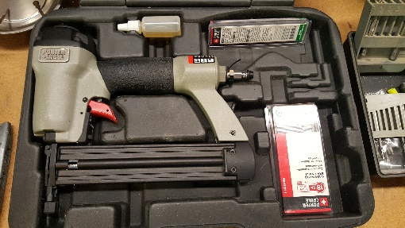

**Porter Cable – Finish Nailer FN250B**

* 16 gauge with nails, case and instructions
* Used on Ebay: $60 (no case or instructions) - $100
* Used on Buya: $60 - $70
* Latest model at Home Depot: $130
* ASKING: $80

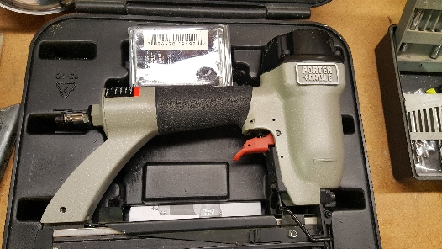

**Porter Cable – Pancake Compressor CF2600**

* 135 psi, 2.0 HP, 6 gallon with instructions
* Includes 24’ rubber hose( ~$25 on EBay)
* Used on Ebay: $48 (diff model but 135 psi/6 gal) - $100 (150 psi/6 gal)
* Similar (though 150 psi) at Home Depot: $100
* ASKING: $70 (incl hose)

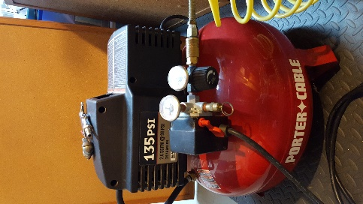

Blueridge Air Nailer (stapler) Model 9025

* 10-25mm fasteners
* Max 120 psi
* Weighs 1.20 kgs
* Similar on EBay:
  + Duofast: $70
  + Bostitch: $45
  + Arrow: $26-$29
  + Wen: $15
* ASKING: $20
* 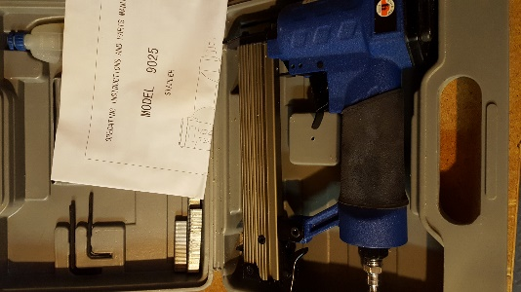

**Central Pneumatic 3/4”Heavy Duty Air impact Wrench – Model 32871**

* Used on EBay and Buya: $80
* ASKING: $70

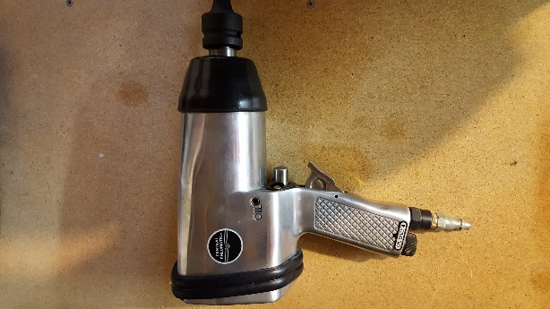

**Blue Ridge Impact Socket Wrench (pneumatic)**

* Includes black coil hose
* With 3 extensions (2-1/2”, 4-1/4”, 9-1/4”) – see these on their own for $8 new
* ASKING: $30

**Craftsman 12-pc impact socket set**

* 1/2" Deep drive
* 3/8” – 1-1/16” sockets
* Ebay: (New) $50-$60
* ASKING: $40

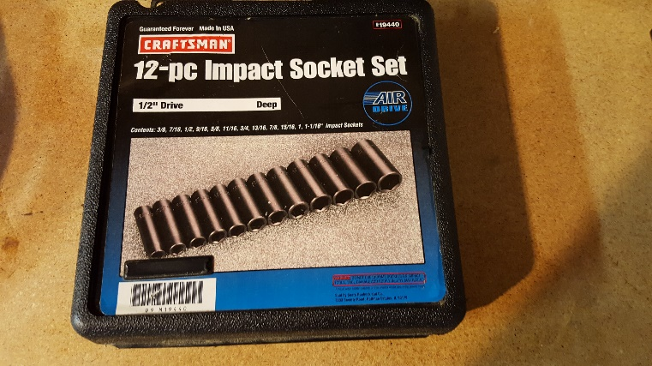

**Ludell Products Pneumatic 5” Air Sander Model AS-5**

* With sanding pads and instructions
* 18,000/RPM
* Hose size: 3/8” diameter
* 90 psi
* Weight: 3.5 lbs

ASKING: $20

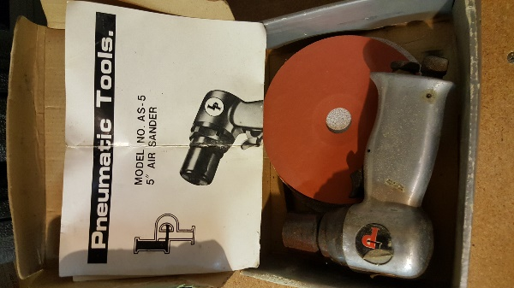

**Sear Craftsman Dual Speed Reciprocating Saw Model 900.271221**

* In case, with instructions and variety of blades
* Similar Used on Ebay: $25-$40 (with case, nails and instructions)
* Similar new at Home Depot: $75-90
* ASKING: $30 (check tag)

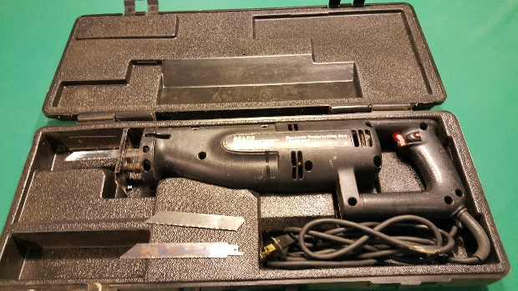

Kreg Jig k4 system

* In case, with all parts, screws, plugs and DVD
* Ebay $40-$60
* New at Lowes: $130
* ASKING: $40

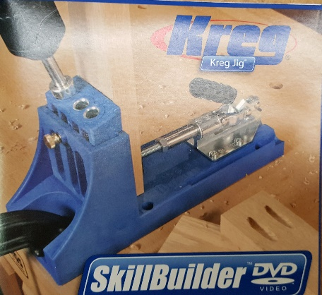

**Drill Doctor 750X – drill bit sharpener**

* In case with instructions
* Ebay: $80-$100
* Amazon: $130 (New)
* ASKING: $80

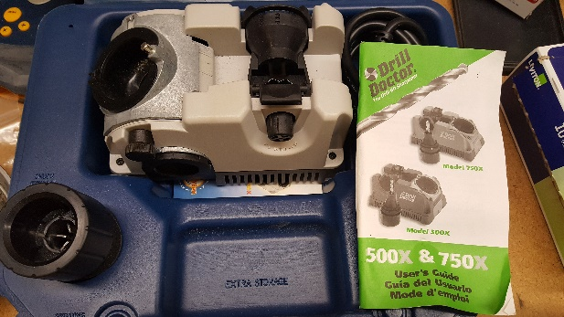

Craftsman 7 1/4 circular saw

* 12 amp
* In case with instructions
* Ebay: $20-$40 (used) $$65 (new)
* ASKING: $30

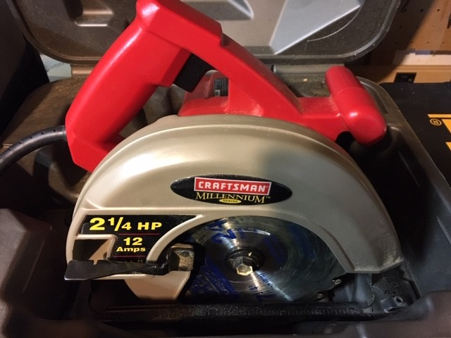

**Dewalt DW511 1/2" Hammer Drill**

* No case
* Ebay: $35 (used) - $65 (new or with case)
* ASKING: $35

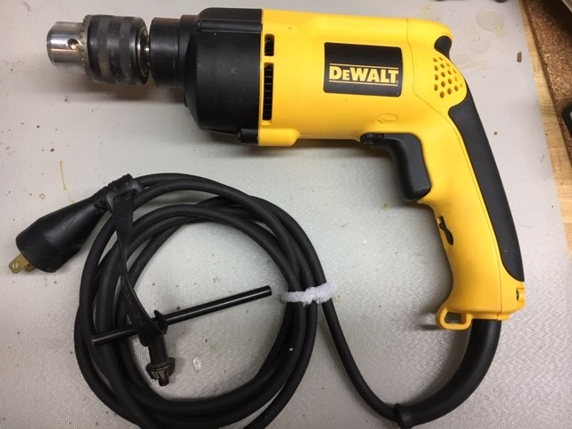

**HIT 600 Bolt Cutter**

* Ebay: $35
* New: $65
* ASKING: $30

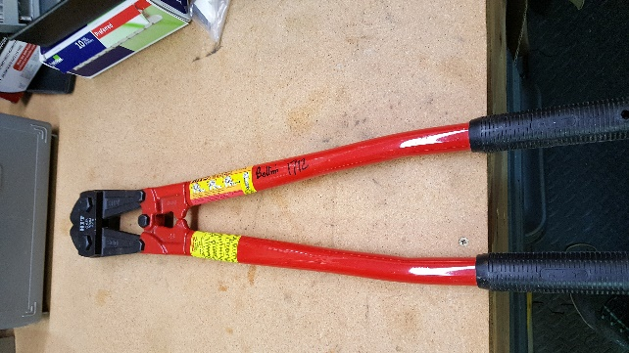

**[Unknown brand] 60-pc Tap and Die set**

* Similar new: $60-$90
* Ebay: $45 (similar)
* ASKING: $45

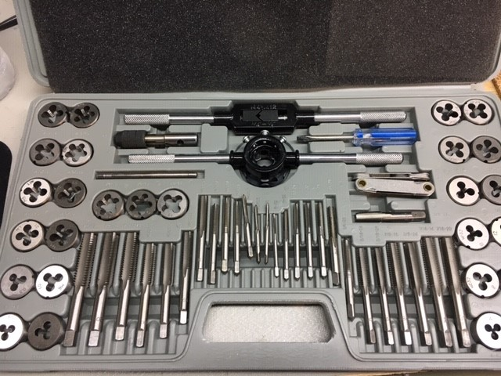

**4 Ton Cable Puller with Safety Hooks**

* New: $120
* Ebay: $65
* ASKING: $50

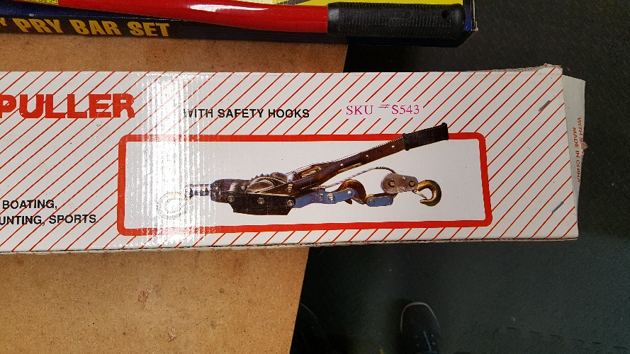

**Craftsman 12” Laser Compound Miter Saw Model 137.21250**

* 15 Amp
* 12” blade
* 4000 RPM
* Similar new (Metabo and Dewalt): $400-$500
* Similar used on Buya and Ebay: $100-$130
* ASKING: $125

**Black&Decker 5” Bench Grinder Model 7901**

* EBay: $35
* ASKING: $30

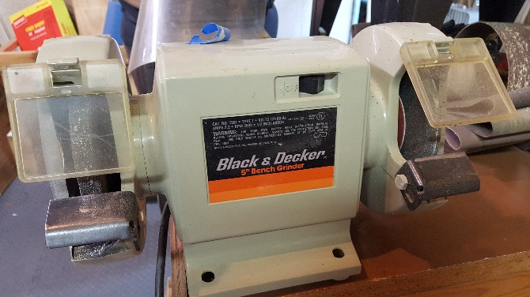

**Stack-on 3 Drawer plus Tool Cabinet**

* Ebay: Similar Craftsman $100
* ASKING: $100

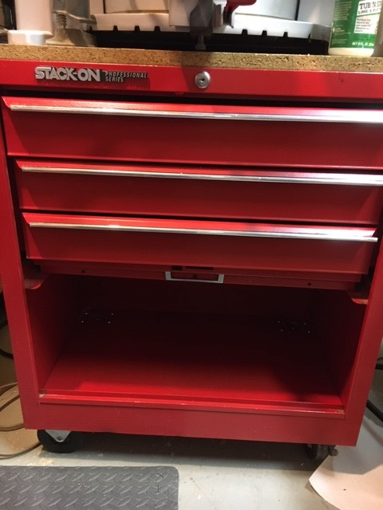

Craftsman 4” Angle Grinder 172.115020

* 5.8-Amp
* No case
* 15 grinding wheels
* Ebay: $15-20 (similar but not dewalt and others)
* New: $35
* ASKING: $20 with Blades

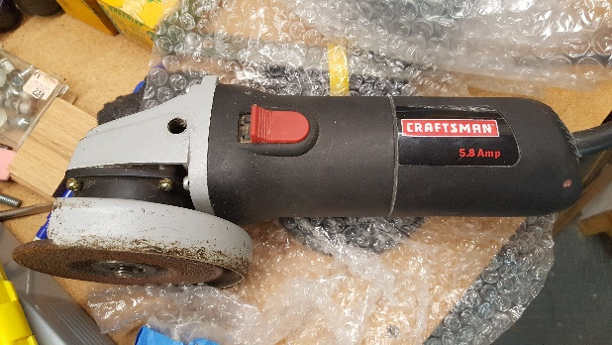 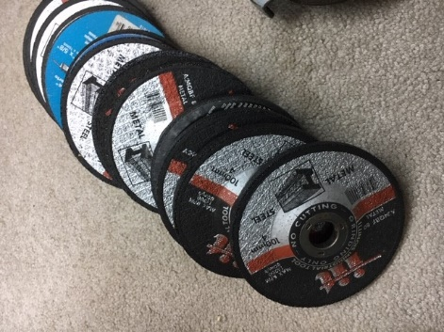

**Misc**

Pipe benders (¾” and ½”)

C-Clamps (2 – 6”)

Long bar clamps (4’, 5’ and 6’)

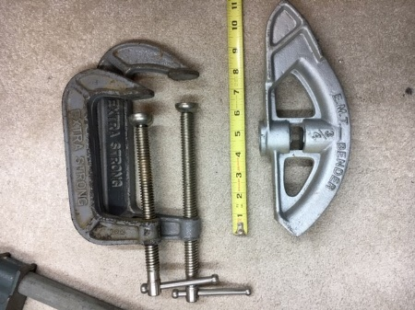 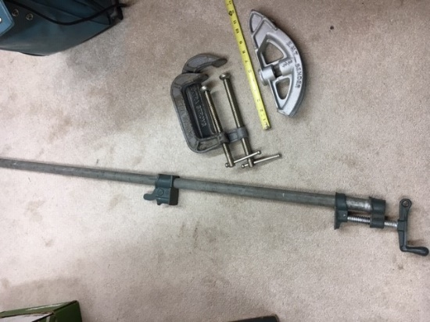

**Electronics**

Radio Shack 4-way distribution amplifier 15-1172

* $25 on Ebay (new)
* ASKING: $15

**ekocycle cube 3d printer**

* Ebay: $450
* Elsewhere used: $100-$200 (similar)
* New (similar but new generations): $400-$1000
* ASKING: $300

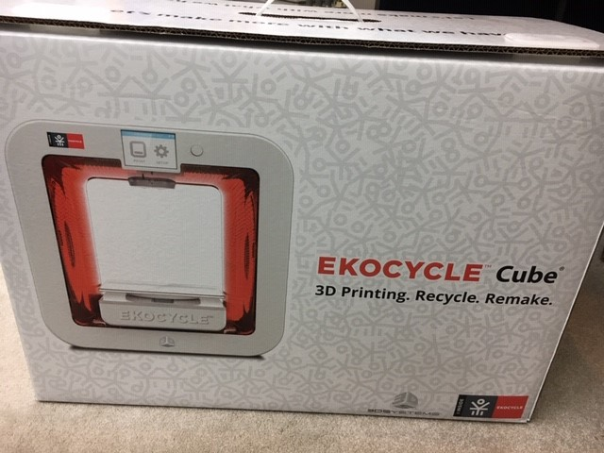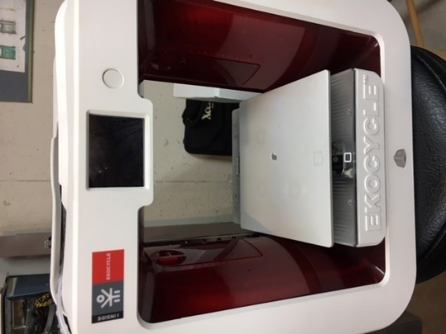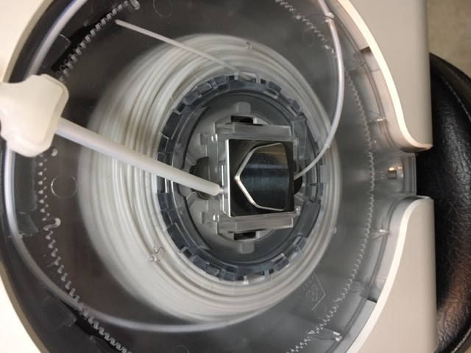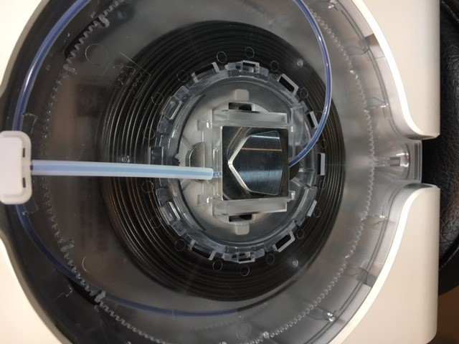

Ham Radio:

